**Curriculum Vitae**

**It is an honor for me to introduce this C.V. with my personal information to apply to work in your group as an employee contributing in the development of this corporation.**

**Personal Information**

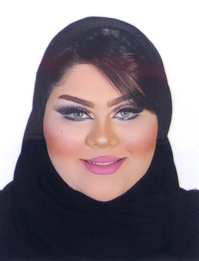Name :Zainab Isa Jaafar Al.Saffar

CPR : 970710356

Nationality : Bahraini

Date of Birth : July 31, 1997

Place of Birth : Jedhafs hospital

Sex : Female

Marital Status : Single

Religion : Muslim

**Contact Details**

Address :House:1828 , Road:7525 , Block:575 , al.Janabiya - Kingdom of Bahrain.

Mob : 33255355

Email : **misblack-7@hotmail.com**

**Objective**

I am self-motivated, ambitious and eager to learn. I am a responsible individual with good communication skills and work ethics besides being creative, focused and highly determined. I am willing to take responsibility and work independently. At the same time, I can work well in teams. Also I can work under pressure.

**Education**

**2009-2012 Zainab Intermediate Girls School**

Graduated and completed intermediate certificate.

**Languages**

I am good in both **English** and **Arabic**.

**Work Experience**

**From December 2013 until October 2014** worked in **Janati beauty center** as a cashier and costumer serves.

**From January 2015 until April 2015** worked in **Mega Mart** as a cashier.

**From July 2015 until November 2015** worked in **The Balm (City Center)** sales and costumer serves.

**4 Months training in 2017 in BMMI (Al-Osra)** as cashier and costumer serves.

**Skills Summary**

●Interpersonal skills:

1. Fast-learner, Hard-worker, and self-initiative.

2. Have good communication skills to deal with the team members and customers effectively.

3. Able to work independently or as a part of a team.

4. Ability to handle stress and pressure in work.

●**Computer Skills:**

1. Microsoft Package: MS Word, MS Power Point.
2. Searching on the Internet.

**Interests**

1. Make-up artist.
2. Discovering new things.
3. Interests in Fashion .